**Practical No 3**

**Aim: Write a code for plotting sector**

**1)The vector is plot as follows in python**

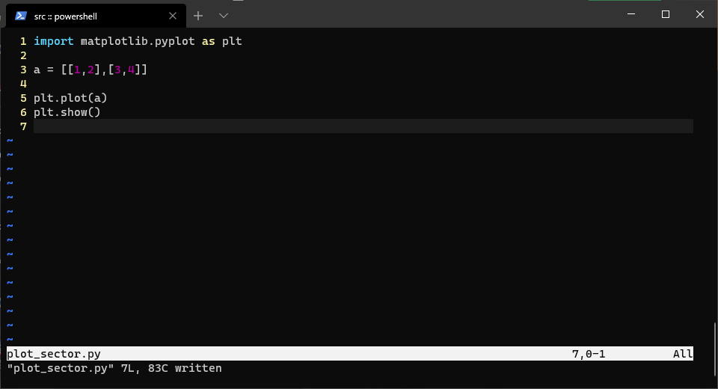

**Output:**

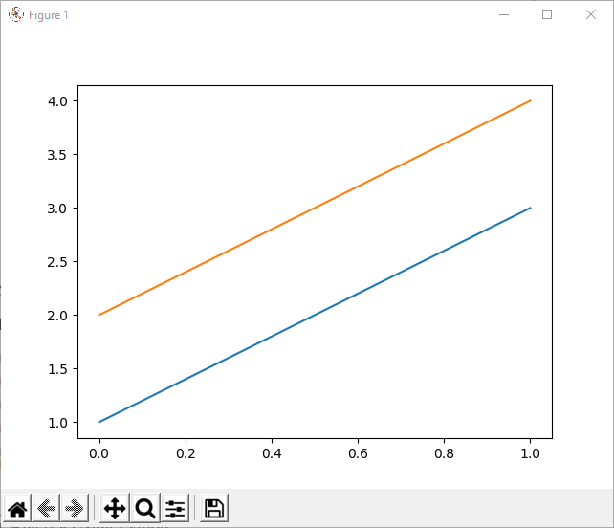

**2)Python code for vector addition is given as follows**

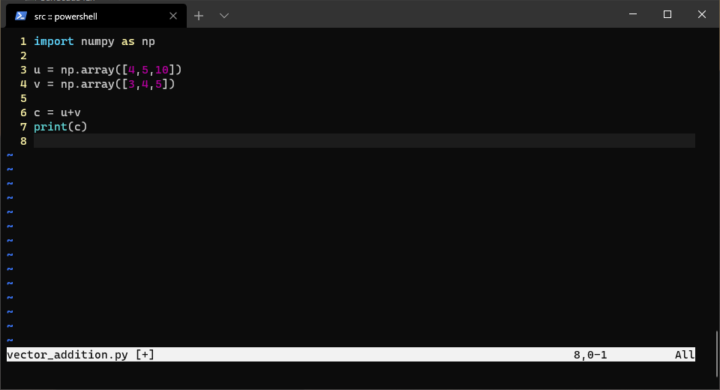

**Output:**

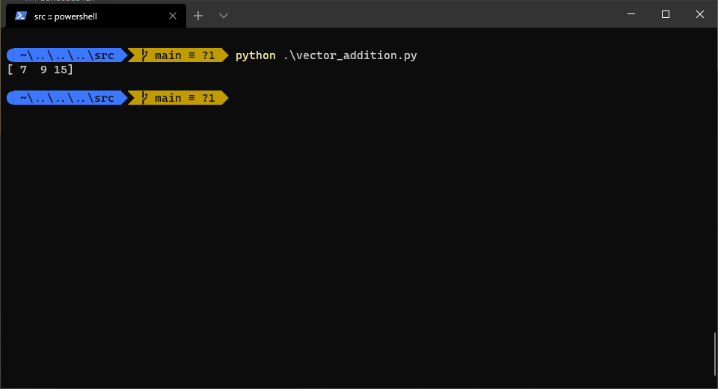

**3)Python code for the above example is given as follows**

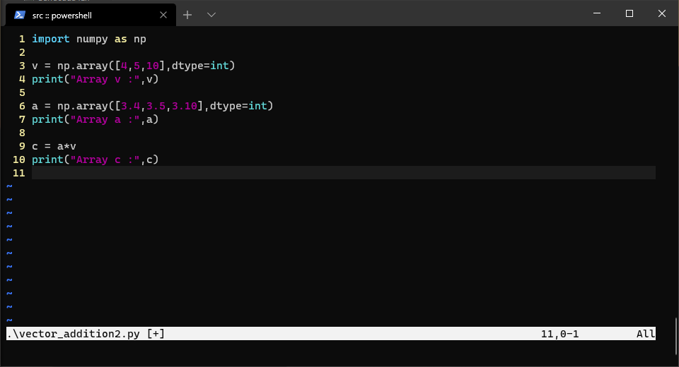

**Output:**

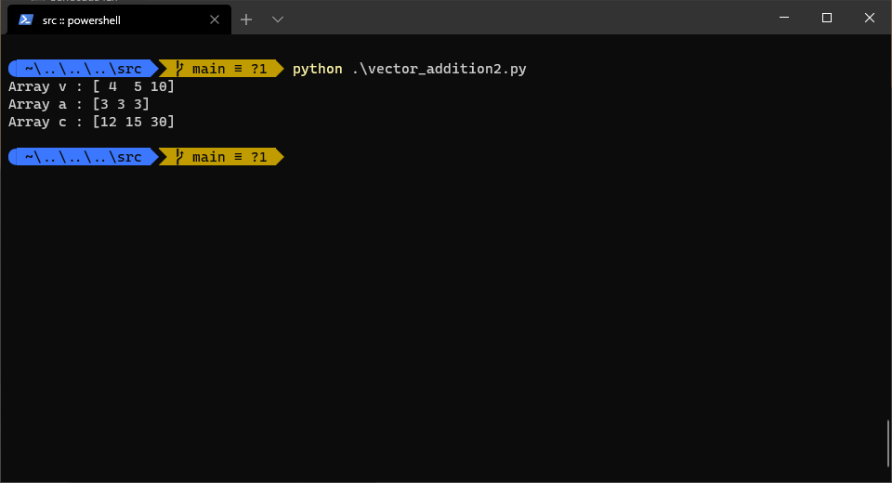

**4)Python code for the dot product is given as follows**

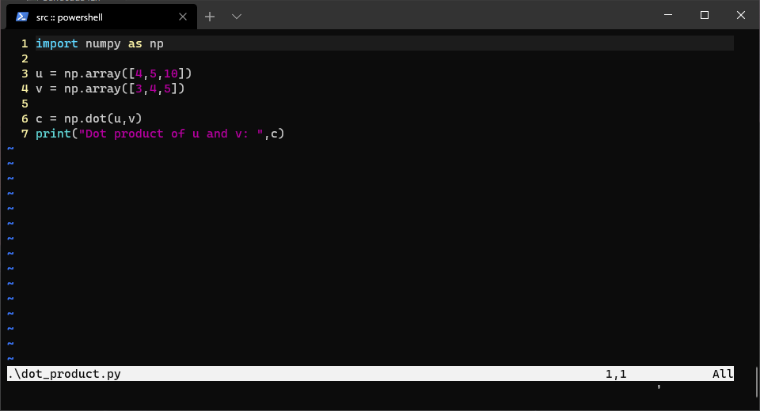

**Output:**

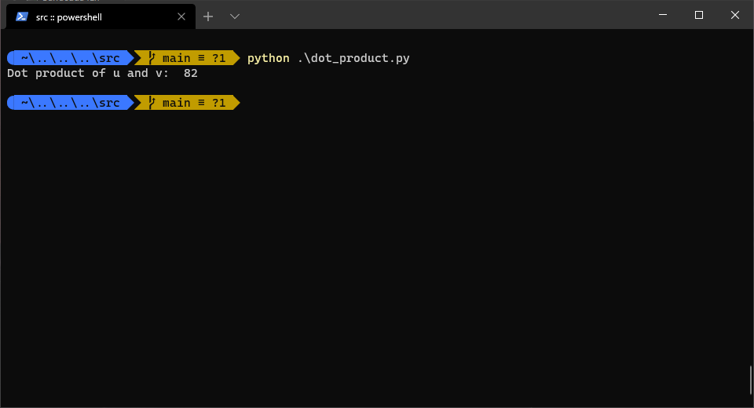

**5) Linear combination of vertex**

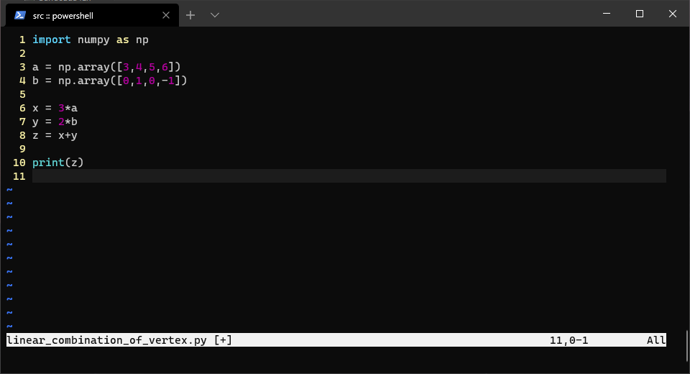

**Output:**

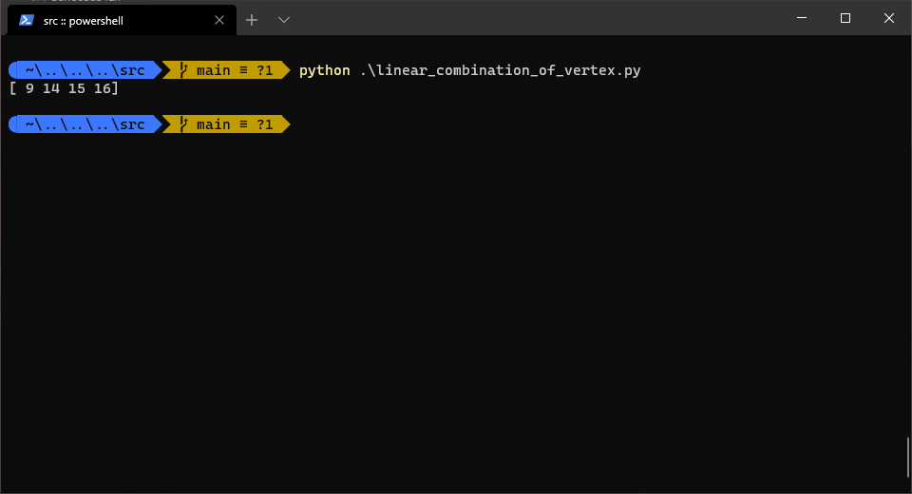

**6)Solve the following system of Linear Equation**

**1x1-3x2-2x3=7**

**2x2+4x3=4**

**-10x3=12**

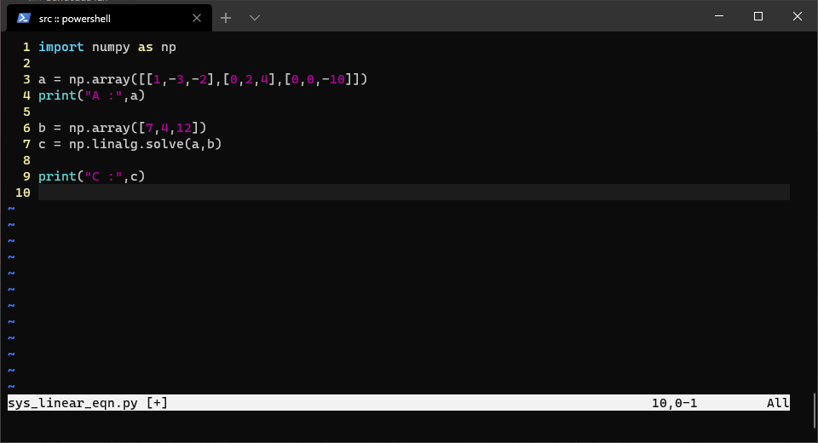

**Output:**

